**CSA0961-JAVA**

**PRACTICE- 6.2**

Try It/Solve It:

1. Describe the difference between a syntax error, a logic error, and an exception.

int number = 10 // Missing semicolon

int a = 5;

int b = 3;

int result = a - b; // Intended to add, but used subtraction

int[] arr = new int[5];

int value = arr[10]; // ArrayIndexOutOfBoundsException

2. What is wrong with the following code? It should print "Hello World!" four times to the screen.

String str = “Hello World”;

for(int i = 0; i < 4; i++);

{

System.out.println(str);

str+= ”!”;

}

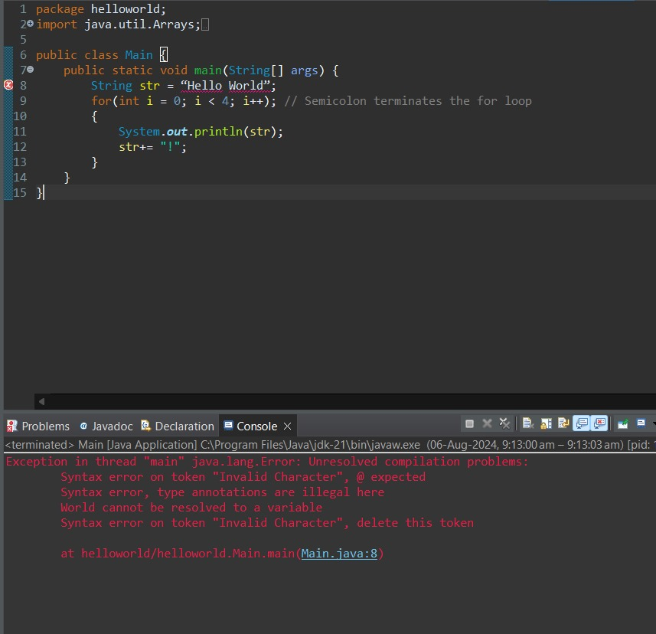

3. Describe an exception that you have experienced in your program before. Explain how it could be handled with a try/catch block of code.

int[] arr = new int[5];

System.out.println(arr[10]); // ArrayIndexOutOfBoundsException

4. Write a segment of code that has:

a. A syntax error

b. A logic error

c. An exception

syntax error:

int number = 10; // Missing semicolon

logic error:

int a = 5;

int b = 3;

int result = a - b; // Intended to add, but used subtraction

exeption:

int[] arr = new int[5];

System.out.println(arr[10]); // ArrayIndexOutOfBoundsException

5. What is the difference between a checked exception and an unchecked exception?

Checked exception:

try {

FileReader file = new FileReader("somefile.txt");

} catch (FileNotFoundException e) {

e.printStackTrace();

}

Unchecked exception:

String str = null;

System.out.println(str.length()); // NullPointerException

